**Table 1.** Descriptive characteristics of unmatched and matched Census Block Groups Between NYCHA and Comparison Groups in New York City for Myocardial Infarction Outcome

|  |  |  |  |  |  |  |
| --- | --- | --- | --- | --- | --- | --- |
|  | **Unmatched**  **(160 vs. 5646 CBGs)** | | | **Matched**  **(118 vs. 256 CBGs)** | | |
|  | NYCHA | Comparison Pool | Std. Diff | NYCHA | Matched Comparison | Std. Diff |
| **Total Population** | 265,433 | 601,167 |  | 196,355 | 404,926 |  |
| **Age Group (%)** |  |  |  |  |  |  |
| percent under 5 | 7.23 | 6.24 | 0.21* | 7.22 | 6.82 | 0.08 |
| percent 5 to 11 | 6.71 | 5.47 | 0.31* | 6.58 | 6.53 | 0.01 |
| percent 12 to 17 | 12.23 | 8.40 | 0.71* | 11.43 | 11.81 | -0.07 |
| percent 50 to 64 | 17.44 | 18.54 | -0.19* | 18.04 | 17.79 | 0.04 |
| percent over 65 | 14.45 | 13.61 | 0.08 | 14.69 | 15.36 | -0.06 |
| **Race/Ethnicity (%)** |  |  |  |  |  |  |
| percent African American | 39.47 | 19.89 | 1.06* | 38.12 | 37.38 | 0.03 |
| percent Hispanic | 50.27 | 26.44 | 1.32* | 50.47 | 50.72 | -0.01 |
| **Federal Poverty Level (%)** |  |  |  |  |  |  |
| percent FPL 100 | 44.70 | 17.98 | 2.07* | 42.64 | 40.69 | 0.15* |
| percent FPL 125 | 9.67 | 4.91 | 0.74* | 9.56 | 10.17 | -0.09 |
| **Year Built (%)** |  |  |  |  |  |  |
| percent under 1950 | 33.61 | 55.40 | -1.01* | 36.86 | 36.83 | 0.001 |
| **Units in Structure (%)** |  |  |  |  |  |  |
| percent under 10 units | 6.65 | 56.66 | -6.25* | 7.57 | 6.93 | 0.07 |
| percent 10-19 units | 7.46 | 5.67 | 0.14* | 7.91 | 7.27 | 0.04 |
| percent 20-49 units | 24.85 | 14.45 | 0.4* | 26.96 | 29.51 | -0.09 |
| percent over 50 units | 60.82 | 23.01 | 1.24* | 57.37 | 56.17 | 0.03 |
| **Pre-Intervention Quarterly Health Outcome Rates (%)** |  |  |  |  |  |  |
| percent MI q1 | 1.78 | 0.91 | 0.33* | 1.41 | 1.47 | -0.02 |
| percent MI q2 | 1.88 | 1.03 | 0.33* | 1.68 | 1.72 | -0.01 |
| percent MI q3 | 1.16 | 0.95 | 0.11* | 1.17 | 1.07 | 0.05 |
| percent MI q4 | 1.53 | 0.89 | 0.21* | 1.59 | 1.44 | 0.05 |
| percent MI q5 | 1.54 | 1.06 | 0.19* | 1.37 | 1.35 | 0.006 |
| percent MI q6 | 1.64 | 1.04 | 0.25* | 1.74 | 1.81 | -0.02 |
| percent MI q7 | 1.35 | 0.91 | 0.18* | 1.14 | 1.13 | 0.007 |
| percent MI q8 | 1.63 | 0.86 | 0.33* | 1.5 | 1.53 | -0.01 |
| percent MI q9 | 2.14 | 0.94 | 0.27* | 1.9 | 1.89 | 0.001 |
| percent MI q10 | 1.96 | 0.99 | 0.3* | 1.95 | 1.76 | 0.05 |
| percent MI q11 | 1.67 | 0.97 | 0.23* | 1.45 | 1.46 | -0.002 |

Abbreviations: NYC=New York City; NYCHA=New York City Housing Authority, Std Diff=standardized differences; CBG=Census Block Group; FPL=Federal Poverty Level

All characteristics are measured using the American Community Survey Data year 2016 with 5-year estimates with the exception of pre-intervention adult myocardial infarction quarterly rates. Matched sample incorporates overlap weights. Values are expressed as means

*Standardized differences >0.1

**Table 2**. Descriptive characteristics of unmatched and matched Census Block Groups Between NYCHA and Comparison Groups in New York City for Stroke Outcome

|  |  |  |  |  |  |  |
| --- | --- | --- | --- | --- | --- | --- |
|  | **All Data**  **(160 vs.5646)** | | | **Matched Data**  **(113 vs. 254)** | | |
|  | NYCHA | Comparison Pool | Std. Diff | NYCHA | Matched-Comparison | Std. Diff |
| **Total Population** | 265,433 | 601,167 |  | 184,631 | 384,944 |  |
| **Age Group (%)** |  |  |  |  |  |  |
| percent under 5 | 7.23 | 6.24 | 0.21* | 6.95 | 6.92 | 0.01 |
| percent 5 to 11 | 6.71 | 5.47 | 0.31* | 6.38 | 6.44 | -0.01 |
| percent 12 to 17 | 12.23 | 8.40 | 0.71* | 11.94 | 11.94 | 0.00 |
| percent 50 to 64 | 17.44 | 18.54 | -0.19* | 17.56 | 17.90 | -0.05 |
| percent over 65 | 14.45 | 13.61 | 0.08 | 15.33 | 15.44 | -0.01 |
| **Race/Ethnicity (%)** |  |  |  |  |  |  |
| percent African American | 39.47 | 19.89 | 1.06* | 37.54 | 36.93 | 0.03 |
| percent Hispanic | 50.27 | 26.44 | 1.32* | 50.46 | 50.65 | -0.01 |
| **Federal Poverty Level (%)** |  |  |  |  |  |  |
| percent FPL 100 | 44.70 | 17.98 | 2.07* | 42.45 | 41.62 | 0.06 |
| percent FPL 125 | 9.67 | 4.91 | 0.74* | 9.13 | 9.69 | -0.08 |
| **Year Built (%)** |  |  |  |  |  |  |
| percent under 1950 | 33.61 | 55.40 | -1.01* | 37.35 | 37.54 | -0.008 |
| **Units in Structure (%)** |  |  |  |  |  |  |
| percent under 10 units | 6.65 | 56.66 | -6.25* | 7.27 | 7.16 | 0.01 |
| percent 10-19 units | 7.46 | 5.67 | 0.14* | 7.82 | 8.16 | -0.02 |
| percent 20-49 units | 24.85 | 14.45 | 0.4* | 27.64 | 29.28 | -0.06 |
| percent over 50 units | 60.82 | 23.01 | 1.24* | 57.13 | 55.27 | 0.06 |
| **Pre-Intervention Quarterly Health Outcome Rates (%)** |  |  |  |  |  |  |
| percent stroke q1 | 1.81 | 1.14 | 0.26* | 1.91 | 1.7 | 0.08 |
| percent stroke q2 | 2.19 | 1.25 | 0.32* | 1.82 | 1.82 | 0.003 |
| percent stroke q3 | 1.96 | 1.22 | 0.26* | 1.79 | 1.78 | 0.004 |
| percent stroke q4 | 2.49 | 1.22 | 0.41* | 2.3 | 2.13 | 0.05 |
| percent stroke q5 | 1.96 | 1.23 | 0.28* | 1.82 | 1.64 | 0.07 |
| percent stroke q6 | 1.72 | 1.24 | 0.22* | 2.04 | 1.80 | 0.10 |
| percent stroke q7 | 1.93 | 1.26 | 0.19* | 1.93 | 2.06 | -0.030 |
| percent stroke q8 | 2.15 | 1.21 | 0.31* | 1.99 | 2.00 | -0.001 |
| percent stroke q9 | 2.43 | 1.32 | 0.33* | 2.28 | 2.36 | -0.02 |
| percent stroke q10 | 2.15 | 1.32 | 0.24* | 2.03 | 1.92 | 0.03 |
| percent stroke q11 | 2.42 | 1.4 | 0.26* | 2.44 | 2.13 | 0.08 |

Abbreviations: NYC=New York City; NYCHA=New York City Housing Authority, Std Diff=standardized differences; CBG=Census Block Group; FPL=Federal Poverty Level

All characteristics are measured using the American Community Survey Data year 2016 with 5-year estimates with the exception of pre-intervention adult stroke quarterly rates. Matched sample incorporates overlap weights. Values are expressed as means

*Standardized differences >0.1

**Figure 1.** Quarterly Incidence Rates of Health Outcomes Between NYCHA population and Comparison Group

a)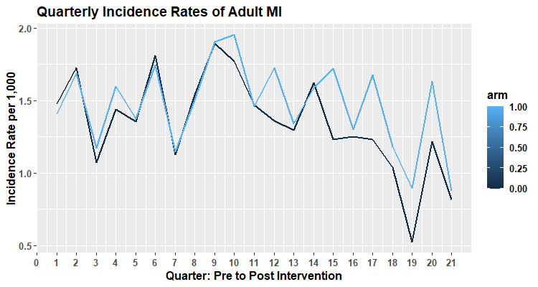

Matched-Comparison (CBG n= 256)

NYCHA (CBG n = 118)

SPARCS Dataset, 2015-2020, Abbreviations MI=Myocardial Infarction, NYCHA= New York City Housing Authority

Weighted Adult Myocardial Infarction Quarterly Rates resulting from Propensity Score Matching on age, race/ethnicity, poverty level, built environment, and pre-intervention adult myocardial infarction quarterly rates

b) 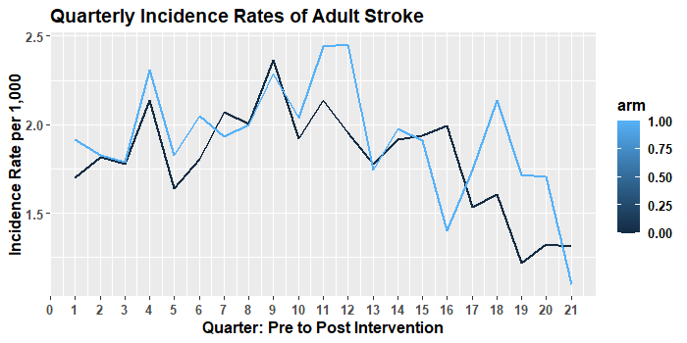

Matched-Comparison (CBG n= 254)

NYCHA (CBG n = 113)

SPARCS Dataset 2015-2020, Abbreviations NYCHA= New York City Housing Authority

Weighted Adult Stroke Quarterly Rates resulting from Propensity Score Matching on age, race/ethnicity, poverty level, built environment, and pre-intervention adult stroke quarterly rates

**Table 3.** Difference-in-Differences estimates comparing outcome rate of change between NYCHA population and comparison group, 2015-2020

|  |  |  |  |  |  |
| --- | --- | --- | --- | --- | --- |
| **Effecte** | **CBG**  **(N obs.)** | **Mean Difference**  **Baseline vs. 24 months Post-Policy**  **MD (95% CI)** | **D-I-D Estimate**  ***(p-value)*** | **Mean Difference**  **Baseline vs. 36 months Post-Policy**  **MD (95% CI)** | **D-I-D Estimate**  ***(p-value)*** |
| ***Myocardial Infarction*** |  |  |  |  |  |
| NYCHAa | 118 | -0.27 (-0.64, 0.09) | 0.23 *(p=0.31)* | -0.28 (-0.77, 0.20) | 0.21  *(p=0.47)* |
| Matched Comparisonb | 256 | -0.51 (-0.75, -0.25) | -0.50 (-0.82, -0.06) |
| ***Stroke*** |  |  |  |  |  |
| NYCHAc | 113 | -0.28 (-0.63, 0.06) | 0.06 | -0.63 (-1.09, -0.17) | -0.01  *(p=0.97)* |
| Matched Comparisond | 254 | -0.35 (-0.58, -0.12) | *(p=0.75)* | -0.62 (-0.93, -0.31) |

SPARCS Dataset 2015-2020. Abbreviations: D-I-D=Difference-In-Differences; CBG=Census Block Group; MI=myocardial infarction

a100% NYCHA Census Block Groups (n=118)

bPropensity score matched Census Block Groups (n=256) matched on age, race/ethnicity, poverty status, built environment, and pre-intervention adult MI quarterly rates

c100% NYCHA Census Block Groups (n=113)

dPropensity score matched Census Block Groups (n=254) matched on age, race/ethnicity, poverty status, built environment, and pre-intervention adult stroke quarterly rates

eD-I-D Estimates and p-values correspond to coefficient associated with treatment time interaction in Mixed Linear regression model between baseline and 36 months’ post-policy. Models including matching weights and control for age category, race/ethnicity, federal poverty level, and built environment